Chapter 2 RESEARCH DESIGN

2.1 Research Objectives

The objective of the proposed research is to:

* Review the current models involved in e-commerce
* Gain insight on the various scopes that determine a secure e-commerce environment

Proper analysis of e-commerce environments acknowledges meaning of electronic commerce, computing or technology policies in place, and security and privacy methods present.

* + 1. Research Problem

The research aimed to understand the appropriate scheme to solve security flaws in e-commerce. With the exponential growth of electronic commerce systems, creating a safe system has been the preceding race. Many variables come with calculating the trustworthiness in e-commerce.

* + 1. Variables and Hypotheses

In the projected experiment there are two independent variables and a single dependent variable. First dependent variable includes the type of connection used during connectivity. Second dependent variable takes account the sample data size. Leading to resultant values for the dependent variable, size of the data breached during interconnectivity. Concluding these variables, the corresponding null hypothesis of the states, there is no significant difference in the size of the data breached between using a secure data connection or a basic data connection.

* + 1. Related Work

Following the research of the topic there were many respectable sources encompassing electronic commerce. There are a wide range of resources relating to security and privacy, these include the security services and software and application security. Unfortunately, there lack studies involving policies of e-commerce, but minimal yet sound information was available. As a result, related work of interest to the incredible electronic commerce include discovering more of the unknown policies of the e-commerce medium. As the legal knowledge and the know how to take advantage of these policies come to the forefront, we can assume the potential of e-commerce could finally begin to strive towards its peak.

2.2 Experiment Design

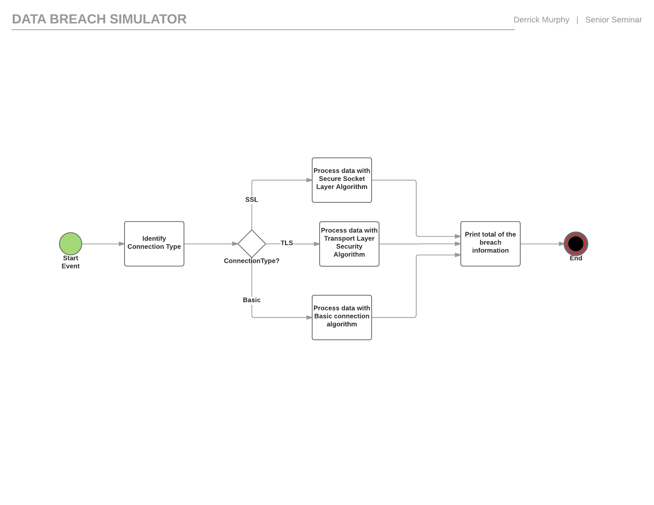

2.2.1 Experiment Description

In the experiment, the independent variable connection type is initially declared by the user. The program generates random results for the second dependent variable, sample size. If the connection is processed on a secure socket layer then the breach algorithm becomes void and the breach results return zero. If the connection is basic this means information is visible by hackers spying on the processes to intercept data. Therefore, the program continues to produce the necessary values to process the breach algorithm. A random number generator establishes a sample size between fifty and one hundred and fifty; along with randomization of the unit of the sample. In the yield of the output a value that is a portion of the original sample size is returned. This is done by dividing the data size with random number between two and six, the return value is the declared breach size.

2.2.2 Data Collection Design

|  |  |  |  |  |  |  |  |  |  |  |  |  |  |  |  |  |  |  |  |  |  |  |  |  |  |  |  |  |  |  |  |  |  |  |  |  |  |  |  |  |  |  |  |  |  |  |  |  |  |  |  |  |  |  |  |  |  |  |  |  |  |  |  |  |  |  |  |  |  |  |  |  |  |  |  |  |  |  |  |  |  |  |  |  |  |  |  |  |  |  |  |  |  |  |  |  |  |  |  |  |  |  |  |  |  |  |  |  |  |  |  |  |  |  |  |  |  |  |  |  |  |  |  |  |  |  |  |  |  |  |  |  |  |  |  |  |  |  |  |  |  |  |  |  |  |  |  |  |  |  |  |  |  |  |  |  |  |  |  |  |  |  |  |  |  |  |  |  |  |  |  |  |  |  |  |  |  |  |  |  |  |  |  |  |  |  |  |  |  |  |  |  |  |  |  |  |  |
| --- | --- | --- | --- | --- | --- | --- | --- | --- | --- | --- | --- | --- | --- | --- | --- | --- | --- | --- | --- | --- | --- | --- | --- | --- | --- | --- | --- | --- | --- | --- | --- | --- | --- | --- | --- | --- | --- | --- | --- | --- | --- | --- | --- | --- | --- | --- | --- | --- | --- | --- | --- | --- | --- | --- | --- | --- | --- | --- | --- | --- | --- | --- | --- | --- | --- | --- | --- | --- | --- | --- | --- | --- | --- | --- | --- | --- | --- | --- | --- | --- | --- | --- | --- | --- | --- | --- | --- | --- | --- | --- | --- | --- | --- | --- | --- | --- | --- | --- | --- | --- | --- | --- | --- | --- | --- | --- | --- | --- | --- | --- | --- | --- | --- | --- | --- | --- | --- | --- | --- | --- | --- | --- | --- | --- | --- | --- | --- | --- | --- | --- | --- | --- | --- | --- | --- | --- | --- | --- | --- | --- | --- | --- | --- | --- | --- | --- | --- | --- | --- | --- | --- | --- | --- | --- | --- | --- | --- | --- | --- | --- | --- | --- | --- | --- | --- | --- | --- | --- | --- | --- | --- | --- | --- | --- | --- | --- | --- | --- | --- | --- | --- | --- | --- | --- | --- | --- | --- | --- | --- | --- | --- | --- | --- | --- | --- | --- | --- |
| |  |  |  |  |  |  | | --- | --- | --- | --- | --- | --- | | Observation | Data Size (MB) | Basic | SSL | TLS |  | | 1 | 87 | 53.49921865 | 22.48057273 | 5.92795818 |  | | 2 | 142 | 98.09918299 | 27.61714738 | 7 |  | | 3 | 118 | 75.28833422 | 10.67705601 | 6.815497543 |  | | 4 | 50 | 29.65590201 | 9.289195418 | 1.593053618 |  | | 5 | 86 | 48.07312299 | 23.5560268 | 2.963380696 |  | | 6 | 94 | 73.29652267 | 18.42611344 | 2.447044089 |  | | 7 | 61 | 47.08759269 | 16.2348205 | 1.064368089 |  | | 8 | 188 | 140.5428537 | 46.66495026 | 12.53381835 |  | | 9 | 105 | 69.21536938 | 17.02656172 | 5.550068949 |  | | 10 | 162 | 105.8014323 | 35.39407623 | 12.50253361 |  | | 11 | 206 | 145.2535231 | 33.6391708 | 2.313798255 |  | | 12 | 129 | 72.7387185 | 30.15153836 | 7.48943409 |  | | 13 | 210 | 89.25599946 | 34.03065549 | 6.902834892 |  | | 14 | 154 | 107.7378107 | 37.57199363 | 7.275868233 |  | | 15 | 84 | 38.10901487 | 17.90715548 | 3.695037604 |  | | 16 | 191 | 122.5292737 | 37.25863912 | 6.303860943 |  | | 17 | 231 | 94.14495595 | 46.15059038 | 11.19645781 |  | | 18 | 56 | 25.9579225 | 12.8198242 | 1.949781493 |  | | 19 | 139 | 109.8801427 | 27.67547063 | 1.820197447 |  | | 20 | 243 | 138.1001134 | 42.72038321 | 7.889532255 |  | | 21 | 128 | 82.60684294 | 27.62834744 | 1.804104997 |  | | 22 | 219 | 167.9681805 | 38.54490308 | 7.661449827 |  | | 23 | 92 | 38.21687478 | 17.60617695 | 6.669640491 |  | | 24 | 208 | 140.5798671 | 41.0723871 | 14.57548242 |  | | 25 | 74 | 31.38636261 | 15.92425605 | 0.793994977 |  | | 26 | 131 | 92.08374946 | 20.3076982 | 7.253330339 |  | | 27 | 227 | 134.3799126 | 35.23742256 | 8.930988927 |  | | 28 | 147 | 73.27680219 | 32.51115421 | 3.527773408 |  | | 29 | 248 | 161.6543734 | 63.37906563 | 6.95031021 |  | | 30 | 186 | 78.74686561 | 47.01227765 | 5.282791274 |  | | Mean |  | 89.50556126 | 29.55052102 | 5.956146434 |  | |  |  |  |  |  |

2.3 Data Analysis Design

2.3.1 Descriptive Statistics Design

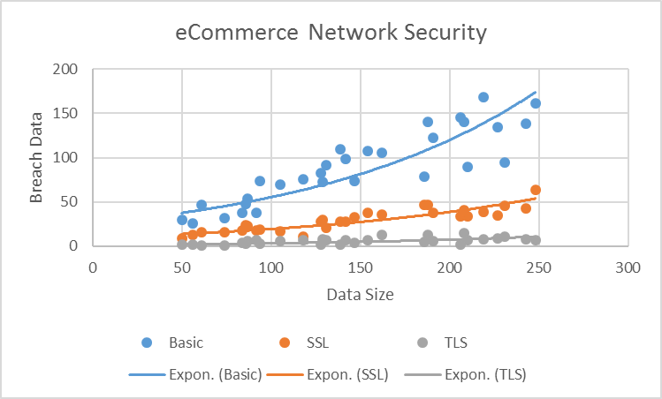

2.3.2 Hypothesis Test Statistics Design

|  |  |  |  |  |
| --- | --- | --- | --- | --- |
|  |  | Basic | SSL | TLS |
| Mean |  | 89.50556126 | 29.55052102 | 5.956146434 |
| Standard Deviation |  | 41.07645655 | 12.85431791 | 3.618271231 |
| Variance |  | 1687.275283 | 165.2334889 | 13.0918867 |
| N |  | 30 | 30 | 30 |
| T-Value |  | 0.193699203 |  |  |
| P-Value(Basic and SSL) | | 6.42837E-09 |  |  |
| P-Value(TLS and SSL) | | 3.06421E-11 |  |  |
|  |  |  |  |  |
|  |  |  |  |  |
| P-Value is lower than 0.05 | |  |  |  |
| Probability the observed results are random are due to chance are low | | | | |
| Conculsion : Null hypothesis is denied | | |  |  |